DECEMBER 2022

VERMONT NATIONAL CRIMINAL JUSTICE REFORM PROJECT
DATA INTEGRATION REPORT

Table of Contents

Data Integration History 2
Data Challenges 2
The Data Integration Planning Process 2
The Business Case for Data Integration – H.546 4
Conclusion 5
Attachment A: Criminal Justice System and Vermont Data Flow 6
Attachment B: Flow Chart Overlayed with Software 7
Attachment C: NCJRP Project Charter 18
Project Overview 18
Project Objectives & Success Criteria 18
Project Scope 19
In Scope: 19
Out of Scope: 20
Project Milestones, Deliverables & Schedule 21
Stakeholders 21
Assumptions, Dependencies & Constraints 23
Project Risks 24
Glossary of Terms 25
Additional References Used 27
Attachment D: Systems Assessment Model 28
Attachment E: Act 142 Summary 32

Data Integration History

Data Challenges
Within the state of Vermont, there is a history of following a traditional approach of relying on transaction- based information systems for data capture and reporting. This model relies on disparate silos of data and functionality, resulting in numerous problems ranging from the inability to access the right data to lengthy delays in obtaining much needed data for analysis and decision making. This perpetuates inefficiencies and compromises the effectiveness of criminal justice practitioners as they try to navigate these systems.

Obtaining relevant data in Vermont can also be challenging due to a lack of information-sharing or the inability to share data. Not only are there challenges in identifying data but there are also nuances in data fields that make it difficult and, in some cases, harmful to draw conclusions from the data. For example, it is harmful to assume that a defendant intended to avoid justice in the case of failure to appear, when in actuality the defendant incarcerated at the time of the hearing.

The Data Integration Planning Process
The National Criminal Justice Reform Project (NCJRP) helped focus the process on strategic planning that furthered the integration of data systems and the use of measurable, high-fidelity evidence-based programs. The long-term vision of this effort has been to develop a data system that allows data sharing and the integration of disparate information technology systems between and among all partners across the criminal justice system in the state. Such a system would provide practitioners at all levels with a comprehensive set of query and analytics tools for improved decision making.

Foundational to this work is the need for access to integrated data from criminal justice and human services. Access to integrated data is critical for the decision-making processes and for measuring the results being achieved. Currently the data systems are siloed with some data flowing through one system to the next. (See Attachment A)

Technology is needed that is scalable to all systems within Vermont criminal justice system, allowing for the comprehensive collection and assessment of data across the criminal justice processes. Through the NCJRP, the Advisory Committee recognized the importance of including data from other agencies beyond that of law enforcement, including courts and corrections. They identified the need to engage stakeholders, conduct a thorough technology and systems assessment, develop a comprehensive strategic plan, and establish a governance structure and staffing to oversee this work.

The long-term vision is to have a single point of reference for the integration of all criminal justice data in Vermont. A system is needed that provides query capabilities, as well as system integration services, allowing for the use of a single, open-source standards-based data portal to facilitate state-wide justice information sharing. The next steps called for bringing the criminal justice community together to develop a strategy that looked beyond the NCJRP. To do this, the NCJRP technical assistance team engaged SEARCH, the premiere justice sharing organization, to help with operationalizing the vision. To help convey the complexity and number of software systems involved in the various functions and roles of the stakeholders expecting to be integrated, Attachment B exists as a flowchart representation overlayed with the software engaged at each phase of the process.

Three objectives were identified:
- To develop and deliver a data infrastructure implementation plan and framework for strengthening governance and multi-agency information sharing among criminal justice and other stakeholders with an initial focus on racial disparities.
- To establish a process to routinely communicate stakeholder technology plans, changes to information sharing needs, policies and practices, and capabilities and gaps. These activities will promote coordination and integration solutions that collectively enhance strategic policy and operational decision making among justice partners within the state.
- To establish a consensus among partners to define the relevance, need, purpose, participating agencies, objectives, and responsibilities of the governance structure. Identify leadership, support, and resources to effectively manage progress toward the defined objectives.

In 2019, the Vermont Department of Public Safety (DPS), as outlined in their Modernization Plan, was in the process of implementing a new computer-aided dispatch and records management system (CAD/RMS) for all law enforcement agencies within the state. This would allow more data to be collected and stored at DPS and help ensure the data is collected effectively and integrated with other systems within the criminal justice system.

To further the data integration work, the Vermont NCJRP team proposed utilizing the funds initially allocated for personnel to support a position within the Agency of Digital Services (ADS). Scheduling meetings, agenda/minutes preparation and distribution, managing deliverables, and participating in committee meetings all takes time and effort – resources which most stakeholders had very little to spare. The support and management function of this initiative was a key component to maintain the project’s initial momentum and continue making progress toward the objectives.

Late in 2021, ADS hired a project director to coordinate the work. The project director and a small group of NCJRP Advisory Committee members met weekly and developed the charter (see Attachment C), the scope of work, a draft governance guide, and with Vermont State Archives and Records Administration (VSARA), a process to assess the state of the data and the processes surrounding it in each state department’s data systems. The assessment serves as a baseline with each of the major stakeholders who would be contributing data to the integrated ecosystem to ensure they are adhering to best practices and principles related to data accountability, transparency, integrity, protection, compliance, availability, retention, and disposition. The exercise is an hour-long self-assessment facilitated by VSARA along with individuals who work closely with the above processes or with the data directly. This is not a performance review or audit being performed by an external party, but instead the assessment functions as an interactive and honest deliberation by the stakeholder over where the stakeholder’s current maturity-level is on a scale of 1 – Substandard up to 5 – Transformational. As principles are identified that are in the 2 – In Development and 3 - Essential range of scores are assessed, an improvement plan and action steps toward further refinement are aligned for the stakeholder to begin improving upon. By having this honest conversation with each stakeholder, areas that could become roadblocks to future integration are proactively identified, especially as data integrity and security of any one stakeholder has the potential to jeopardize the integration as a whole. See Attachment D for more details on the assessment.

The Business Case for Data Integration – H.546
Simultaneously, H.546, which created a Division of Racial Justice Statistics (DRJS) which became the business case for the data integration work, was winding its way through the Racial Disparities in the Criminal and Juvenile Justice System Advisory Panel (RDAP) and the Legislature.

Members of the Office of Racial Equity have joined the project team since the passage of H.546/Act 142 and will be proceeding with future requests to ADS for continued project collaboration efforts. See Attachment E for more details on the Act 142 Summary.

The RDAP was created to investigate and make policy recommendations to end racial disparities and address systemic racism in Vermont’s criminal and juvenile justice systems by Act 54 of 2017. The second report of the RDAP, released in December 2020, recommended that state legislators create a dedicated agency for the analysis of criminal justice disparities in the State of Vermont and an associated community advisory council to guide the equitable implementation of race/ethnicity data collection and analysis efforts. The Legislature then requested that the RDAP reconvene to write a third report informing the legislators of the group’s recommendations for setting up a dedicated criminal justice statistical analysis agency focused on racial disparities. The resulting bill, H.546, incorporated recommendations from the RDAP’s third report released in November 2021. H.546 was signed into law as Act 142 by Governor Phil Scott on May 27, 2022.

The DRJS is to be housed within the Office of Racial Equity (ORE) to leverage ORE staff knowledge and resources in furthering the dismantling of systemic racism across the state. The DRJS is charged with collecting and analyzing criminal justice systems data, along with any other data sources necessary to identify racial disparities in the state. Once the DRJS identifies racial disparities, the members of the Office of Racial Equity are tasked with working to remedy those disparities through policy changes, program development, and community outreach. The DRJS’ enacting statue also creates a Racial Justice Statistics Advisory Council (RJSAC). The RJSAC is comprised of seven community members with lived experiences relevant to the collection of criminal justice data. One member is appointed by the Governor and six members are nominated by community-based organizations who serve communities of color and their intersectional gender, sexual, and romantic minority communities in Vermont. The members of the RJSAC oversee the DRJS to ensure that the experiences of people of color are equitably reflected in all data collection and analysis efforts. Both the DRJS and RJSAC have a duty to report to the RDAP monthly to ensure that their work is aligned with the vision of the RDAP in recommending the creation of the DRJS.

Conclusion
Overall, this project is the summation of over several years of effort spread across varying and disparate initiatives that have unified and culminated in establishing the Division of Racial Justice Statistics within the Office of Racial Equity and constructing this Data Integration plan that these groups can carry forward toward a tangible fruition in the near future. As a theme, data integration arose as early as 2017 as an obvious improvement that would provide significant insight, efficiency, and will encourage data-informed decision-making. This would enhance visibility, transparency, and ease of identifying trends across the Department of Public Safety (Law Enforcement agencies), the Department of Corrections, the Judiciary, and many other tangentially involved stakeholders who are engaged throughout the process. By relying on the expertise of third party institutions, including Crime Research Group (CRG, Inc.) and SEARCH and others who have helped additional state governments draft similar plans, we believe that this effort is ready to be handed off to the ORE and DRJS and brought forward into a living state mechanism of accountability, innovation, and on-going systemic refinement within the State of Vermont.

Attachment A: Criminal Justice System and Vermont Data Flow

The goal of this document is to reflect the general flow of the criminal justice system alongside the software that the State of Vermont uses to process the data created and maintained in the process. Each shape/color represents an individual system used to enter, maintain, and process data by the various stakeholders engaged throughout the process. Aside from the Vermont Justice Information Sharing System (VJISS) helping to automate the passage of data from law enforcement to the courts and pre-trial stakeholders, most other data transitions are expected to be done manually at this time. A data integration of these nearly siloed repositories would create an expected recovery of hours and help foster better data integrity across our systems. The outcome would be far more insightful data reporting for all stakeholders to leverage for future change and continuous improvement initiatives.
Images of the flowchart are broken down on the following four pages.

Attachment B: Flow Chart Overlayed with Software

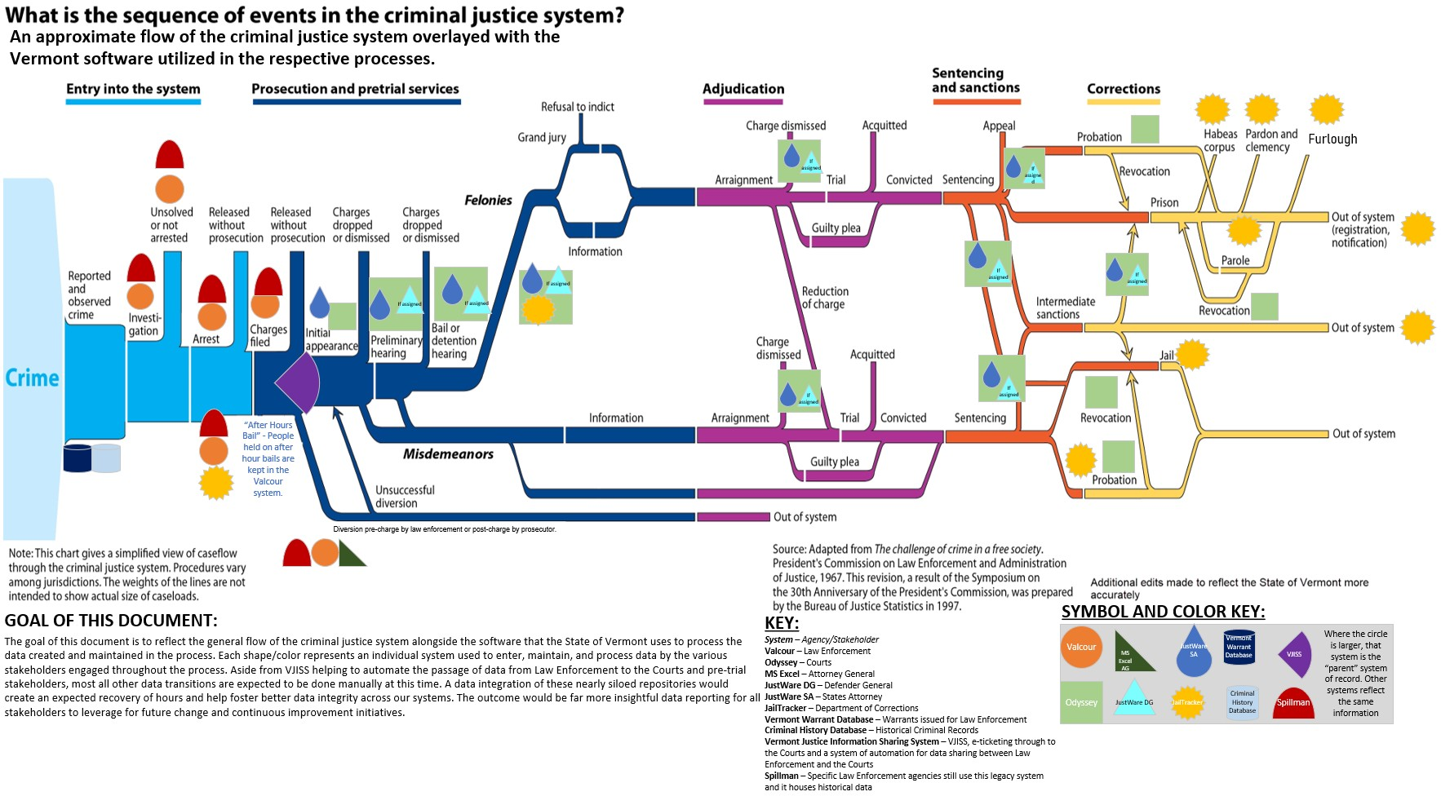

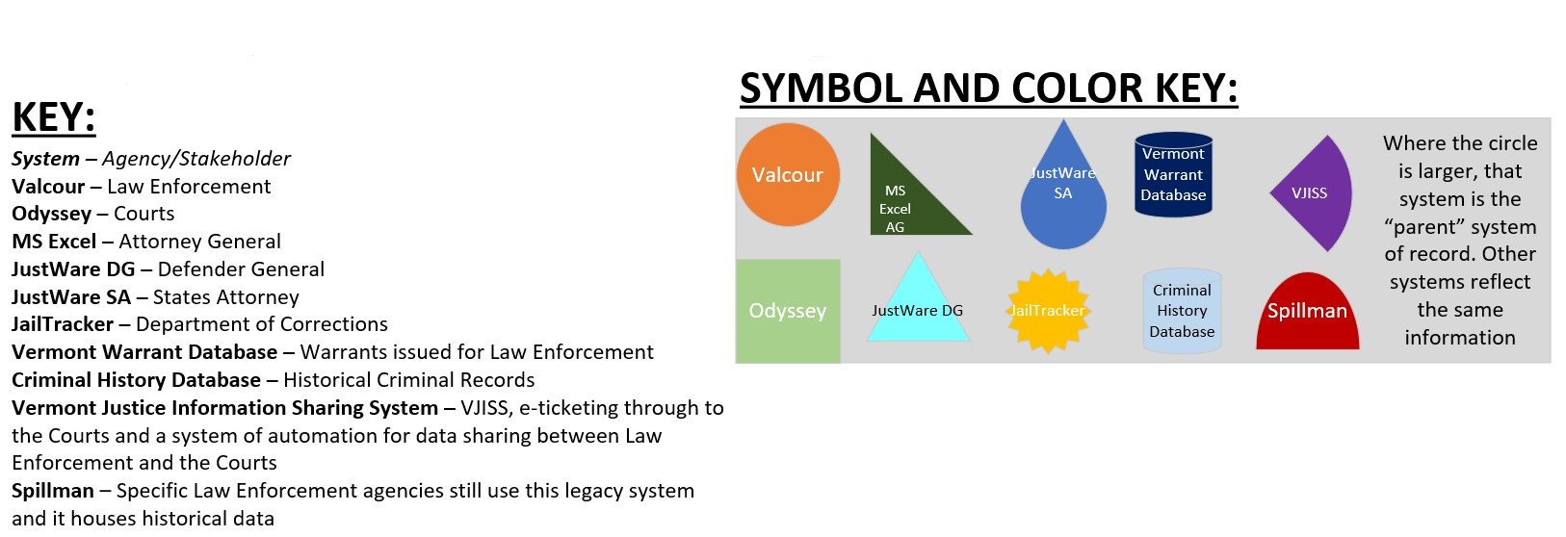

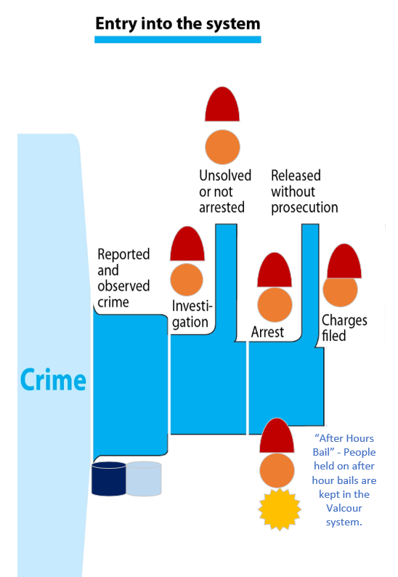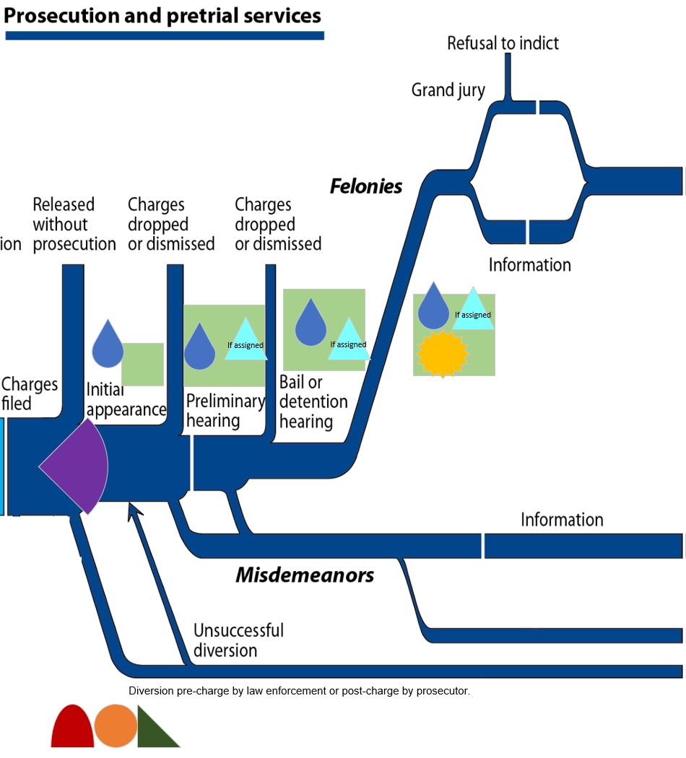

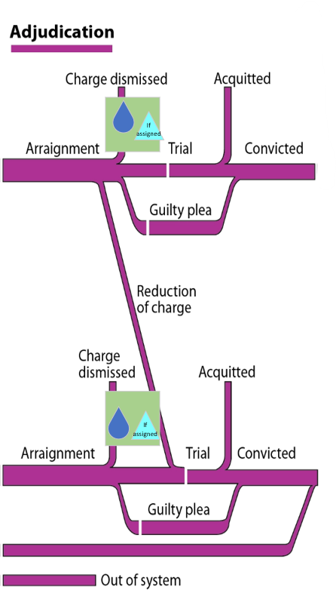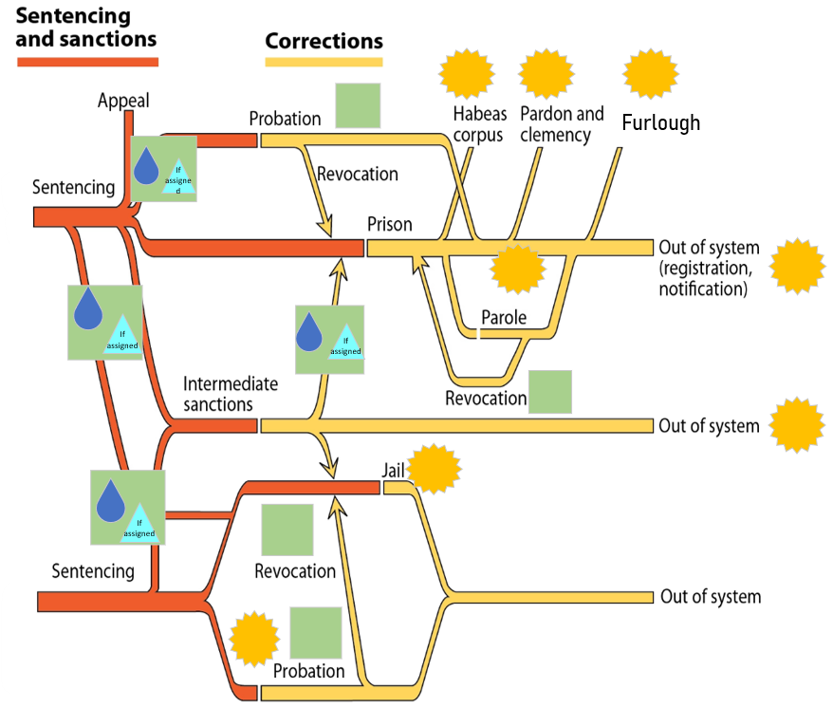

Attachment C: NCJRP Project Charter

Project Overview
This project will support changes to criminal justice policy and leverage improvements to the records management system and enhanced data integration and multi-jurisdictional governance of justice information sharing efforts. The work will be to first baseline the data necessary for stakeholders to maintain the necessary integrity and quality of records management to support the integration, document how the processes of discovery and policy change will take place and construct an overall framework for governance and stakeholder management throughout the data integration implementation through to maintenance and operation once complete.

Project Objectives & Success Criteria
# | Objective | Success Criteria
1 | Implement a Data Integration Plan that aligns all Stakeholder Groups and the data they produce or utilize into an operational ecosystem. | The Data Integration Plan is implemented by/before XX/XX/XX24.
2. | Consensus and approval from NCJRP Core Team to confirm the plan outlined for integration. | Before closing out the planning period, the NCJRP Core Team will have reached a consensus and received formal approval on  this document.
3 | Establish a system or board of governance to maintain the ongoing development of the Data Integration. | Board members and system of governance established prior to the Data Integration Plan being executed by/before XX/XX/22.
4 | Reduce the amount of manual labor required to perform an integration of this data currently performed by Crime Research Group. | The Data Integration Plan, any produced reporting and dashboards, and the collective function of this implementation should reduce any manual need to integrate data sets by the completion of the project.
5 | A Systems Governance baseline assessment performed with all applicable stakeholder’s records management and departmental improvement plans scaffolded. | Completing a Systems Governance baseline with each applicable stakeholder prior to the Data Integration Plan execution  ~XX/XX/2022.
6 | Improving reporting and visibility into demographic criminal justice data. | A publicly accessible dashboard for generalized demographic reporting is online with accurate information by/before XX/XX/XX24.

Project Scope

In Scope:
  - Build with Meaningful Reporting Centered on Racial Equity, as an Output: Standardized development processes so all potentially produced reports meet a set of defined criteria to deliver meaning, value, insight, and detailed data (where applicable) to inform legislative and community shaping decisions.
    - Report Ideas ("Pie in the Sky" Exercise) - Without knowing the data, what types of reports do we expect to see? This output can drive early data element investigation.
    - Research Standard Existing Reports from other State Departments/Data Repositories
  - Stakeholder Definition: Defining who will provide data and who will view/utilize the reports will help to inform the shared spaces and integration necessitated.
    - Which agencies will provide access to what types of data?
    - Who receives or gains access to these reports and databases?
      - Detailed case level information and reporting
      - Data obscured demographic views and "publicized" view
    - Permission Types or Access-Levels Defined
    - Public Facing Sites/Data Repositories to Integrate with (and garner feedback from stakeholder)
  - Governance Definition: A decision-making process or structure that will enable, authorize, and support policy, business process operations, and technology resources necessary to provision and access data assets.
    - A specific area of business’ lead or process owner would also be key informants to these decisions.
    - Identify expungement processes and any expectations around what data is required to be expunged under those circumstances.
    - Identify public or ready to go data sets with a high level of integrity.
  - Data Sharing: How do we ensure that data from the origination point is to be shared appropriately to enable authorized users to pull information and view reporting to help them answer questions quickly. Agreements and data protection rules will need to be exhaustively identified.
    - Potential Output: Template MOU for data sharing to be used when future stakeholder seek access to data in the future.
    - NOTE: The Data Integration itself is not a deliverable of this initiative.
  - Data Element Definition: High-level identification of what data is collected that is in scope of this effort (data fields, KPIs, standard reporting expectations)
    - Identification of existing data across agencies and departments that will be considered core for inclusion in the central dataset. Some readily identifiable and prioritized examples:
      - Data collected by Valcour
      - Spillman data (including any process for access and preservation)

      - Offender Management System (OMS) - Includes a data dictionary and schema
      - Data collected by Tyler Technologies as judiciary data
    - Strategy development for accessing data to be readily available (existing reports and extracts).
      - Strategy must include/incorporate any data that exists in external/partitioned repositories (not centralized, ie. Spreadsheets or separate applications)
    - Strategy development for processes for the future identification of data gaps.
    - NOTE: An all-encompassing glossary of data elements will not be considered in scope of this initiative. The team members will use expert judgement to discern which elements will need to be considered core to this initial integration effort.
  - Data Integration Categories and Permission/Access Types: Sharing of data would breakdown into separate use cases and their defined integration point(s)
    - Public Facing Sites/Data Repositories to feed (Data Mapping needed)
      - API for public facing dashboard with data elements constrained to specific sets with automated and compliant data masking applied.
    - Interdepartmental (data accuracy for delineation/useful extrapolation)
    - Report Distribution Lists - Defined Departments and Distribution Lists which stakeholders should receive resulting reporting.
    - It is assumed all permission and access types will adhere to the CJIS Security Policy v5
    - A “Data Trust Document” should be established for all users of or contributors to the data (see example in the Appendix from the State of Virginia).
    - NOTE: The Data Integration itself is not a deliverable of this initiative.
  - Process Scaffolding for Future Gap Analysis: High-level identification of processes or protocols that will need to be written or considered in order to direct future requests for additional data elements to be added to any system or process.
    - Any data element identification is to be a separate or sequential project (see out of scope).
    - Documenting the process needed for field adjustments and additions as future reporting requests dictate.
  - Sustainability Plan: Definition and identification of costs, program details, FTEs and any reasonable expectations to maintain this program and function on an on-going and sustained basis into the future when this service request ends.

Out of Scope:
  - Identification or Addition of New Data Elements & Downstream Process & Policy Changes: There will not be and explicit identification of additional data elements needing to be added at this time. Simply the process for what any future gap analyses should follow.
    - NOTE: It is identified that this means underlying integrations, additional data elements and all outpouring reports are not being delivered as an output of the completion of this investigative project.

Project Milestones, Deliverables & Schedule

Milestone/Deliverable | Target Delivery Date or Range
Project Start Date | 11/22/2021
Project Charter/Scope of Work Refinement Period | 11/22/2021 – 02/28/2022
Governance Board and Methods Established | 03/01/2022 – 08/30/2022
Data Sharing and Data Element Election Process Definition | 03/01/2022 – 08/30/2022
Data Access and Permissions Definition | 03/01/2022 – 08/30/2022
Data Integration Plan and High-Level Work Breakdown Structure  Definition | 03/01/2022 – 08/30/2022
Planning Service Request Estimated End Date | 08/30/2022
System Governance Baselines (by applicable stakeholder) | 08/31/2022 – XX/XX/XX24
Reporting “Pie in the Sky” & Standard Reporting Questionnaire (by applicable stakeholder) | 08/31/2022 – XX/XX/XX24
Data Integration Plan Execution Phase | 08/31/2022 – XX/XX/XX24

Stakeholders
Stakeholder Group | Impact | Business Lead | Technical Lead
Department of Corrections | provides data on the  incarcerated and community supervised population | Monica Weeber | Chrysta Murray
Crime Research Group (CRG) | Has contract to perform State Statistical Analysis Center responsibilities, no provision of  data | Robin Joy Karen Gennette | Robin Joy
Vermont Crime Information Center (VCIC) | Provides data on criminal histories  NIBRS | Jeff Wallin | Kim Prior
Legislature | Informed | N/A | N/A
Governor Scott | Executive Order, Informed | N/A | N/A
Department of  Public Safety |  | Jen Morrison | Kim Prior
Department for Children and  Families |  | Tyler Allen Elizabeth Morris | Mike Nagle
Office of the  Defender General |  | Matt Valerio | Mary Deaett  Greg King
Office of the  Attorney General |  | Julio Thompson | Jay Bailey

Criminal Division (of the Office of the Attorney  General) |  | Domenica Padula | Jay Bailey
Civil Rights Unit (within Public Protection Division) |  | Julio Thompson - Director | Jay Bailey
Community  Justice Division |  | Willa Farrell  Erin Jacobsen | Jay Bailey
Court Diversion and Pretrial Services |  | Willa Farrell
Department of State’s Attorneys  & Sheriffs |  | Evan Meenan | Al Coccagna
Public Representative (Member of the  Public) | Critical to ensure transparency and community engagement. | Appointed by ???
Vermont Chief  Data Officer |  | Kristin McClure | Josiah Raiche
Valcour Governance Board | Both from a Sheriff/County Department engagement and as a statewide case manager  - Sheriff Mark Anderson (Windham County Sheriff Department & Statewide Case Management System) | Sheriff Mark Anderson | Betty Wheeler
Judiciary |  | Scott Griffith | Marcia Schell
The Office of Racial Equity | Primary stakeholder of this integration work. | Xusana Davis – Executive Director | Jay Greene - Racial Equity Policy and  Research Analyst
Crime Victim Services | Has data from victim service providers, compensation fund  and uses data | Jennifer Poehlmann
Vermont State Archives and Records  Administration | Help to standardize life-cycle management requirements and legal requirements around  records management. | Tanya Marshall | By stakeholder group.

Assumptions, Dependencies & Constraints
# | Type  (Assumption, Dependency or Constraint) | Description
1 | Act 5 of 2017 | A bill that promotes public safety by protecting Vermont residents from compulsory collection of personally identifying information, or dissemination of that information for purposes of establishing a mandatory federal registry or  database.
2 | Criminal Justice Information Service (CJIS) | Federal regulations on who can access criminal history information and for what purpose https://www.fbi.gov/services/cjis
3 | VT Expungement Statutes/Rules | An assumption has been made that any potential impacts from H.534 or other Expungement related statues and rules will be navigated with decisions made as to how the eventual maintenance and disposition of records will be managed on- going. At this time, the assumption is that the integrated data repository implemented would not become any official source of record, but instead the source data repositories would each respectively remain the official source of record  to their data committed.
4 | Public Record Statutes | 28 V.S.A. § 107 Offender and inmate records; confidentiality;  exceptions; corrections
5 | National Information  Exchange Model | NIEM is a common vocabulary that enables information exchange across diverse public and private organizations.

Project Risks
# | Risk Description | Impact (H/M/L) | Probability (H/M/L) | Risk Plan
1 | Resource shifts could cause gaps from the Project Planning to Project Execution phases. | H | H | Continue open lines of communication between Portfolio Managers about resource time commitment and expectations. Continue awareness of transitions of primary stakeholders.
2 | Complexity of the systems and/or the data and how it’s gathered within the system could lead to momentum loss on delivering an integrated system. | H | H | By managing the early portions of alignment and assessment with each department, areas of improvement will be targeted earlier in the hopes that each area will be able to increase integrity and other key principles to ensure a smoother integration process.
3 | New or amended legislation has the potential to impact this deliverable or the agencies involved. | H | H | Accepting this risk as a known circumstance of state governmental projects.
4 | Resource bandwidth or availability to find qualified candidates or positions. | H | H | Accepting this risk as a known of the current labor circumstances.
5 | Collaboration, cooperation, and trust are required across multiple entities for the success of this project. | H | H | Proactively engage with the stakeholder groups through the governance assessment and emphasizing long-term benefits of cooperation with this initiative.
6 | Human and financial resource gaps and the inability to fill the gap, both identified and unidentified, may contribute to project  delay. | H | H | We will have to engage with the stakeholder group based on the constraints to budget and hiring practices that pertain to the respective area.

Glossary of Terms
- Access Management - Access management is the process of identifying, tracking, controlling, and managing a user's permission to use a system, application, or service, while preventing use by unauthorized persons.
- Ad Hoc Report - An ad hoc report is a report designed and created by a user for a particular purpose or business necessity.
- Canned Report - A canned report is a predefined, preformatted report, provided as a standard feature of a solution or created within the solution by a user, that is available within a solution or published and distributed by the solution.
- Data – A fact or statistic collected for reference or analysis.
- Database - A database is a collection of structured data or information organized for search and retrieval, typically stored electronically in a computer.
- Database Administrator - A database administrator is a specialized computer system administrator who determines the most effective and efficient way to collect, design, secure, and store data in a data repository, and then maintains that environment so data can be readily retrieved for operations.
- Dataset - A dataset is a collection of related data items that may be accessed individually, in combination, or managed as a whole entity. A dataset fulfills a specific business purpose, such as a service provided to a Vermonter, and is organized into some type of structure like a database (in whole or in part), a data warehouse (in whole or in part), a spreadsheet, or a data extract file.
- Data Center - A data center is the department in an enterprise that houses and maintains back-end information technology systems and data stores, e.g., its mainframes, servers, and databases.
- Data Element - A data element is a unit of data for which the definition, identification, representation, and permissible values are specified by means of a set of attributes.
- Data Governance - One of the ten functional areas of data management, Data Governance is the exercise of authority and control (planning, monitoring, and enforcement) over the management of data assets. The Data Governance function guides how all other data management functions are performed. Data Governance is high-level, executive data stewardship.
- Data Governance Council - A Data Governance Council is an inter-department group of executives and leaders who have the insight, vision, and authority to create policies and procedures to achieve the Data Integration and Governance mission, vision, and goals. This group has enterprise-wide authority over data management.
- Data Integration – The process by which data is consolidated among data stores, applications, and organizations into consistent forms, either physical or virtual.

- Data Lake - A data lake is a centralized data repository that is capable of storing both traditional structured data (row and column), as well as unstructured data (non-tabular raw data in its native format, such as video, image, binary, etc.).
- Data Repository - A data repository is one or more data storage entities that hold data, make it available for use, and organize it in a logical manner for transactional, analytical, or reporting purposes.
- Data Stores - A data store is a repository for persistently storing collections of data, such as a database, a file system, or a directory, in which the data can be of any type, such as text, image, video, audio, etc.
- Data Use Agreement - Data use agreements (DUA)—also referred to as data sharing agreements or data use licenses—are documents that describe what data are being shared, for what purpose, for how long, and any access restrictions or security protocols that must be followed by the recipient of the data.
- Data Warehouse - A data warehouse is a (usually) large store of data accumulated from a wide range of sources within an enterprise and used to guide management decisions. A data warehouse employs data deduplication and star schema techniques to aid in high- performance querying.
- Deduplication - Deduplication is the task of merging disparate database records that refer to the same underlying entity in a given database and the potential removal of superfluous records that were intended to refer to, but do not refer to, the underlying entity.
- Enterprise - An enterprise is a system of one or more organizations and the solutions they use to pursue a shared set of common goals.
- Entity - An entity is a real-world subject or object, such as an individual person, business, publication or consumer product, that has a unique identity and that can be distinguished from any other entity.
- Identity Management - Identity management is the set of processes and technologies for identifying, authenticating and authorizing an individual or group of individuals on an application, system, or comprehensive IT environment.
- Key Performance Indicators (KPI) - A key performance indicator is a measurable value that demonstrates how effectively an organization is achieving key business objectives. Organizations use key performance indicators at multiple levels to evaluate their success at reaching targets. High-level key performance indicators may focus on the overall performance of the enterprise, while low-level key performance indicators may focus on processes in programs or departments, such as service delivery or a call center.
- Master Data Management - Master data management is control over master data values to enable consistent, shared, contextual use across systems, of the most accurate, timely, and relevant version of truth about essential business entities.

- Master Person Index - A master person index is an entity’s authoritative source for person identity data, such as gender, date of birth, race and ethnicity, social security number, current address, and contact information for persons across disparate systems within the entity and providing a unique identifier for each person.
- Procedure - A procedure is a series of steps, taken together, to achieve a consistent result.
- Process - A process is the conversion of an input into an output.
- Record Management System – Any system of record, physical or virtual, which aids in the management for efficient and systematic control of the creation, receipt, maintenance, use, and disposition of records.
- Sensitive Data - Sensitive data is data or information in physical or electronic form that must be protected from unauthorized access. Data with personally identifiable information will often be automatically considered sensitive and require authorization to access.
- Stakeholders – A stakeholder is a group or individual with a relationship to the change, the need, or the solution.
- Subject Matter Expert (SME) - A subject matter expert is a stakeholder with in-depth knowledge of a topic relevant to the business need or solution scope.
- Unique Identifier - A unique identifier is a data element that is associated with a single entity and is intended to be unique among all identifiers used for that entity within a given dataset.
- User - A user is a person that has authorized access to a solution.
- User Provisioning - User provisioning is an identity management process that ensures an organization's user accounts are created, given proper permissions, changed, disabled, and deleted in accordance with that organization's policies.

Additional References Used
  - Actionable Intelligence for Social Policy (AISP)
    - Centering Racial Equity – A Toolkit for Centering Racial Equity Throughout Data Integration: Centering Racial Equity – Actionable Intelligence for Social Policy (upenn.edu)
    - Introduction to Data Sharing & Integration: AISP-Intro-.pdf (upenn.edu)
  - Bureau of Justice Statistics – Criminal Justice System Flowchart: Criminal Justice System Flowchart | Bureau of Justice Statistics (ojp.gov)
  - Checklist for Building and Maintaining a Data Warehouse (csgjusticecenter.org)
  - Criminal Justice Information System (CJIS) Security Policy v5: CJIS Security Policy v5
  - H.546/Act 142: Bill Status H.546 (vermont.gov)
  - Virginia Data Trust Documentation: Commonwealth Data Trust (virginia.gov)
  - Washington Statute for Justice Integration Network Board: 1605-S.SL.pdf (wa.gov)

Attachment D: Systems Assessment Model

The State of Vermont’s Systems Assessment Model is a tool for measuring systems governance maturity for the purposes of assessing current information capabilities and understanding where supports are needed to improve maturity and mitigate risks. Developed by the Vermont State Archives and Records Administration, which administers the Statewide Records and Information Management Program under which state and local government programs operate, the Model is based on Generally Accepted Recordkeeping Principles® and industry standards and best practices in the areas of information and data governance, trustworthy systems, and risk management.

The Systems Assessment Model measures systems governance maturity on five-point scale that ranges from sub-standard (low) maturity to transformative (high) maturity across the eight Generally Accepted Recordkeeping Principles: (1) Accountability; (2) Transparency; (3) Integrity;
(4) Protection; (5) Compliance; (6) Availability; (7) Retention; and (8) Disposition. The Model was piloted by the National Criminal Justice Reform Project to assess its potential for helping understand the data integration capabilities among stakeholders and their systems and was found to be a valuable tool.

1. Accountability
Senior-level staff member oversees system with authority to delegate responsibilities to appropriate individuals. Agency adopts policies and procedures to guide personnel and ensure system auditability.
Level 1 | Senior-level oversight of system and delegation of responsibilities does not exist, is minimal, or carried out in an ad hoc manner.
Level 2 | Need for oversight and delegation is recognized but ill-defined, incomplete, just  beginning to take shape, or only marginally effective.
Level 3 | Senior-level staff member is responsible for oversight and delegation and there  are established goals around system accountability.
Level 4 | Oversight and delegation are proactively being integrated into the administration and operations of the system to meet accountability goals.
Level 5 | Governance is led, not just sponsored, by superiors and senior-level staff member is supported in ensuring system accountability goals are reviewed, revised, and  met and system is auditable.

2. Transparency
Documentation related to personnel, processes, technologies, and the lifecycle management of written and recorded information created, received and/or managed in the system is available to all staff and interested parties and is verifiable.
Level 1 | Documentation does not exist, is minimal, or carried out in an ad hoc manner.

Level 2 | Need for documentation is recognized but ill-defined, incomplete, just beginning  to take shape, or only marginally effective.
Level 3 | Documentation exists and there are established goals around the transparency of  the system.
Level 4 | Documentation is proactively being integrated into the administration and  operations of the system to meet transparency goals.
Level 5 | Transparency is a key component of the system and stakeholders are consistently  satisfied with system transparency and verifiability.

3. Integrity
Written and recorded information created, received and/or managed in the system has a reasonable and suitable guarantee of authenticity and reliability.
Level 1 | Reasonable and suitable guarantee of authenticity and reliability does not exist, is  minimal, or is ad hoc.
Level 2 | Need for improved integrity is recognized but ill-defined, incomplete, just beginning to take shape, or only marginally effective.
Level 3 | Integrity exists and there are established goals around the integrity of information  created, received and/or managed in the system.
Level 4 | Integrity is proactively being integrated into the administration and operations of  the system to meet integrity goals.
Level 5 | Integrity is a key component of the system and there are controls for ensuring  information integrity and information assets are routinely audited.

4. Protection
Written and recorded information created, received and/or managed in the system has a reasonable and suitable guarantee of protection.
Level 1 | Reasonable and suitable guarantee of protection does not exist, is minimal, or is ad hoc.
Level 2 | Need for improved protection is recognized but ill-defined, incomplete, just  beginning to take shape, or only marginally effective.
Level 3 | Protection exists and there are established goals around the protection of  information created, received and/or managed in the system.
Level 4 | Protection is proactively being integrated into the administration and operations of the system to meet protection goals.
Level 5 | Protection is a key component of the system and there are controls for ensuring protection is auditable and loss or inappropriate or inadvertent disclosure are  rare.

5. Compliance
Written and recorded information created, received and/or managed in the system complies with Federal and state legal requirements as well as Agency’s own policies and procedures.
Level 1 | Clear understanding of compliance requirements does not exist, is minimal, or is  ad hoc.
Level 2 | Need for improved compliance is recognized but ill-defined, incomplete, just  beginning to take shape, or only marginally effective.
Level 3 | Compliance exists and there are established goals around systems compliance,  including for the written and recorded information it contains.
Level 4 | Compliance is proactively being integrated into the administration and operations  of the system to meet compliance goals.
Level 5 | Compliance is a key component of the system, roles and processes for compliance  are understood and audited with continual improvements.

6. Availability
Written and recorded information maintained in the system can be retrieved and produced in a timely, efficient, and accurate manner as needed.
Level 1 | Information is not readily available when needed, is minimal, or is ad hoc.  Employees are unsure where to store information and discovery is difficult.
Level 2 | Need for improved availability is recognized but ill-defined, incomplete, just beginning to take shape, or only marginally effective.
Level 3 | Availability exists and there are established goals around the availability of  information and system functionality provide ready access as needed.
Level 4 | Availability is proactively being integrated into the administration and operations  of the system to meet availability goals.
Level 5 | Availability is a key component of the system, there is a measurable return on  investment, and there are continuous improvements to the availability of information.

7. Retention
Written and recorded information created, received and/or managed in the system is retained in the system until retention requirements have been met.
Level 1 | Clear understanding of retention requirements does not exist, is minimal, or is ad hoc. There is no current record schedule or system is not designed to manage  retention.
Level 2 | Need for a record schedule or retention management is recognized but ill-defined,  incomplete, just beginning to take shape, or only marginally effective.
Level 3 | Record schedule exists and there are established goals around managing the  retention of the written and recorded information in the system.

Level 4 | Record schedule and retention management is proactively being integrated into  the administration and operations of the system to meet retention goals.
Level 5 | Retention is a key component of the system and lifecycle management is  understood and audited with continual improvements.

8. Disposition
Written and recorded information created, received and/or managed in the system is securely and appropriately disposed when retention requirements have been met.
Level 1 | Clear understanding of disposition requirements does not exist, is minimal, or is ad hoc. There is no current record schedule or system is not designed to manage disposition.
Level 2 | Need for a record schedule or disposition management is recognized but ill-  defined, incomplete, just beginning to take shape, or only marginally effective.
Level 3 | Record schedule exists and there are established goals around managing the  disposition of the written and recorded information in the system.
Level 4 | Record schedule and disposition management is proactively being integrated into the administration and operations of the system to meet disposition goals.
Level 5 | Disposition is a key component of the system and lifecycle management is  understood and audited with continual improvements.

Attachment E: Act 142 Summary
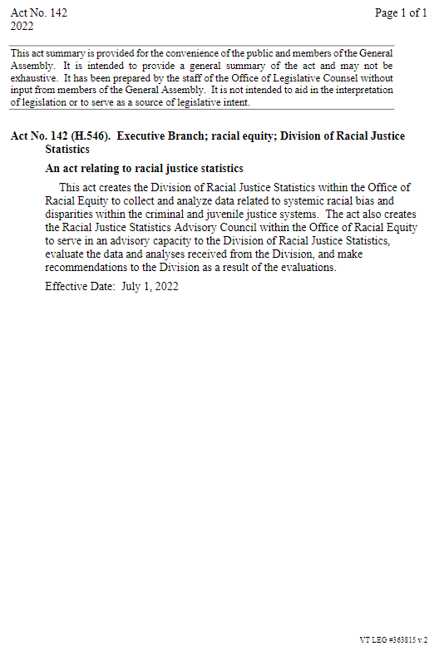

NCJRP supports people-first language; this is the name of the Vermont DOC case management system.
NCJRP supports people-first language; this is the title of the Vermont statute.

