A Preliminary Descriptive Analysis of NIBRS Arrest Patterns in Vermont from 2018-2020
National Incident Based Reporting System (NIBRS) data record three types of arrests: summons/ citation, custodial, and arrests made on sight without a warrant. Chart 1 plots the number and type of arrests by month. The vertical line illustrates the day Vermont declared a Covid State of Emergency: March 13, 2020. However, various Vermont agencies began responding to Covid before the state of emergency was issued. For example, the Department of Corrections began acting to secure the safety of the prisoners in February of 2020, shortly after the White House declared Covid a public health emergency. These measures included bringing awareness to law enforcement and the judiciary about the desire to reduce the carceral population, including by restricting the use of bail and custodial arrests.
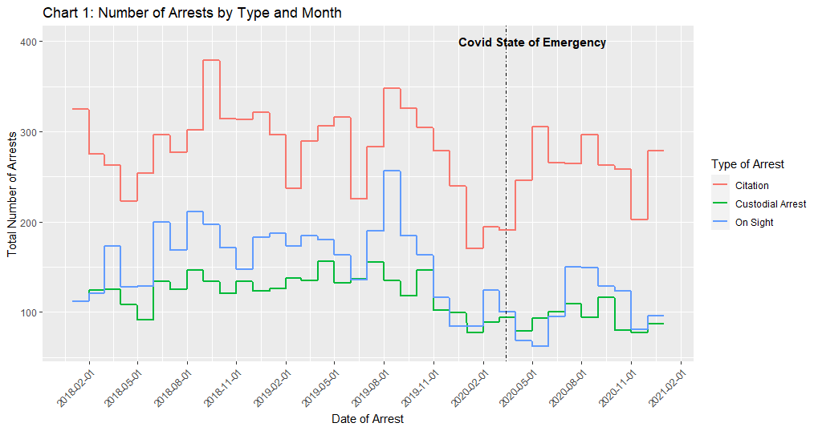
Table 1 highlights that all types of arrests were declining in the months preceding the state of emergency, however the proportion of arrests that were by citation grew during 2020.
Table 1. Number of Arrests by Type and Year
 | 2018 | 2019 | 2020
Total Arrests | 6,960 | 7,046 | 5,289
Citation | 3,542 | 3,449 | 2,933
Custodial | 1,477 | 1,579 | 1,095
On Sight | 1,941 | 2,018 | 1,261

Proportion of Citations to Total Arrests
When the size of the groups being assessed are not the same, it is best practice to use percentages as they allow for easy comparison of unequal groups. As such, NIBRS data were analyzed to see if the proportion of citations to the proportion of total arrests significantly differed by year, offense category type, or the race of the arrestee. The following 3 tables depict the results of these proportion tests. First, in Table 2 the analysis of the data by year shows that of the proportion of citations to the total number of arrests was not statistically significant from 2018 to 2019. However, the proportions of 2018 to 2020 and 2019 to 2020 were statistically significant (p = .0000.) This indicates that the measures adopted by law enforcement during the Covid period affected the type of arrests that were made.
Table 2. Type of Arrest by Year
 | Year of Arrest
Type of Arrest | 2018 | 2019 | 2020
Citation | 50.9% | 48.9% | 55.5%
Custodial Arrest | 21.2% | 22.4% | 20.7%
On Sight | 27.9% | 28.6% | 23.8%

Next, for offense categories containing a sufficient number of arrests, the data were analyzed to determine if the pre-COVID proportion of citations to the total number of arrests was statistically different from the proportion post-COVID. In Table 3, the results indicate statistically significant (p< .01) differences in the proportions for assault offenses, drug/narcotics offenses, and larceny/theft offenses. This means that for the three types of offenses, the difference in the proportion of citations issued pre-Covid and those issued post-Covid is not due to chance, but rather law enforcement practices during Covid. The difference in the proportion of citations to the proportion of total arrests for fraud was not statistically significant.
Table 3. Type of Arrest by Offense Category Before and After Covid
 | Offense Category
 | Assault Offenses | Drug/Narcotics Offenses | Fraud Offenses | Larceny/Theft Offenses
Pre-COVID
Citation | 40.1% | 30.9% | 67.6% | 72.3%
Custodial Arrest | 31.1% | 21.5% | 14.6% | 9.1%
On Sight | 28.8% | 47.6% | 17.8% | 18.6%
Post-COVID
Citation | 47.1% | 47.0% | 67.3% | 80.5%
Custodial Arrest | 26.3% | 16.9% | 23.3% | 8.8%
On Sight | 26.6% | 36.1% | 9.4% | 10.7%
Significance | p= .000* | p= .000* | p= 1 | p= .007*

Data were also analyzed to compare differences in the proportion of citations to the total number of arrests by the race of the person arrested. American Indian and Alaskan Native individuals who were arrested were excluded from this analysis because there were too few people recorded. Table 4 illustrates that the difference in the proportion of citations to total arrests was significant (p< .01) for White, but not for Asian or Black individuals arrested. The proportion of Black citations to White citations was also statistically significant.
Table 4. Type of Arrest by Race Before and After Covid
 | Race of Person Arrested
 | Asian | Black | White
Pre-COVID
Citation | 45.9% | 41.3% | 50.6%
Custodial Arrest | 25.5% | 36.0% | 20.5%
On Sight | 28.6% | 22.7% | 28.9%
Post-COVID
Citation | 57.1% | 44.8% | 58.0%
Custodial Arrest | 14.3% | 31.5% | 19.3%
On Sight | 28.6% | 23.7% | 22.7%
Significance | p= .2602 | p= .2978 | p= .000*

Summary and Next Steps
Overall, this preliminary analysis demonstrates that measures adopted by law enforcement during the Covid period affected the type of arrests conducted. Post-Covid, law enforcement officers moved towards using more citations as opposed to custodial arrests. However, the impact of this shift is unknown. Further research should cross reference NIBRS data, Vermont’s court data, the Department of Correction’s public use data, and criminal histories to answer other pertinent questions. For example, triangulation of these data sources could answer questions about arrest patterns before and after Covid like: (1) Did injury or use of weapon influence the type of arrest? (2) Was the type of arrest influenced by the relationship between the individual identified as the victim and the individual identified as the alleged perpetrator? (3) Were there jurisdictional differences in the use of custodial arrests? (4) What were the characteristics of those who were arrested vs. cited to appear?
The data sources could also address questions related to criminal case processing/use of pretrial detention before and after Covid. Some potential questions include: (1) How long did individuals charged with a crime spend in pre-trial detention? (2) Did bail amounts change during the pandemic? (3) How did the pandemic influence length of time to disposition? (4) How did the pandemic influence length of time from arrest (custodial, summons, or on sight) to arraignment?
Further, analysis of the data sources can address questions about re-arrest rates for individuals on pre-trial release. For example: (1) What was the pre-trial re-arrest rate for those who were cited vs. those who had a custodial arrest? (2) Did the arrest rate change during the pandemic year(s)? (3) What crimes were people re-arrested for while awaiting trial? (4) How many days/months/years until the first re-arrest while awaiting trial?
The answers to these questions would allow researchers and policy makers to better understand how the increased use of citations may have impacted public safety.

Please note that CRG, Inc. has received Bureau of Justice Statistics (BJS) funding to conduct a complete descriptive analysis; this report is a preliminary descriptive analysis focused solely on NIBRS data.
For the purposes of this analysis, the pre-covid period consists of citations and arrests that occurred before the State of Emergency declaration (January 2018- March 12, 2020) while the post- covid period includes citations and arrests that occurred between March 13, 2020- December 31, 2020).
Two proportion z-tests compare whether proportions in groups are the same, or whether they equal certain given values.

