Delaware NCJRP Outcome Evaluation Plan

The Delaware NCJRP Team proposes to conduct a rigorous outcome evaluation of the Delaware Department of Corrections (DOC) recently implemented cognitive behavioral/employment training intervention. The intervention is comprised of the Cognitive Behavioral Intervention-Employment Module (CBI- EMP) derived from the University of Cincinnati’s Cognitive Behavioral Intervention-Core Curriculum (CBI-CC), and the Five-for-Five employment training readiness program. Each component of the intervention is described in detail in a subsequent section of this document. For purposes of brevity, the intervention will be referred to as the CBT-Training Intervention throughout the remainder of this document.
The development and implementation of the CBT-Training Intervention and this outcome evaluation plan are the result of several years of NCJRP-supported work aimed at reforming reentry and reducing recidivism in Delaware. As detailed in prior Delaware NCJRP reports, strategic planning efforts undertaken in Phases I and II of the NCJRP project identified a host of needed reentry reforms, including expanded cognitive behavioral therapy and job readiness programming within the DOC. To help meet this need, the DOC worked collaboratively with the Delaware Criminal Justice Council, the University of Delaware (UD) “evaluation” team, NCJRP staff and others to develop and initially implement the CBT-Training Intervention during Phase III of the NCJRP. UD researchers also engaged in formative evaluation and evaluability assessment work focused on the CBT-Training Intervention during Phase III. In addition to its importance in Delaware’s reentry reform and recidivism reduction strategy and its potential for replication or adaptation in other jurisdictions, the efforts from Phase III have demonstrated that the CBT-Training Intervention is ready for rigorous outcome evaluation.
The remainder of this plan is organized in the following manner. To begin, the Intervention and its constituent parts are described in detail, including how each part is being delivered to Delaware DOC clients and planned delivery in 2023-2024. This is followed by the outcome evaluation plan, including 1) the research questions UD intends to answer and hypotheses that will be tested; 2) the research design including sample size, data resources and outcome measures and analytic strategy to be used, 3) dissemination information, and 4) a 36-month timeline, for the outcome evaluation work. Appendix A identifies key evaluation personnel and a proposed budget for conducting the outcome evaluation.
Points of contact for the proposed evaluation:
Principal Investigator, Daniel O’Connell, PhD, Senior Scientist/Assistant Professor, UD
CO-Principal Investigator, Christy A. Visher, PhD, Professor, UD
Valarie Tickle, Grant Coordinator, Delaware Criminal Justice Council
Heather Zwickert, Chief of Planning, Delaware DOC Planning & Research Unit

The Delaware DOC CBT-Training Intervention
According to the National Institute of Corrections, Cognitive Behavioral Therapy (CBT) has been shown to be effective in reducing the recidivism of criminal offenders and promoting desistance from crime CBT programs have been shown to work in both community and institutional settings, and they have become a staple of rehabilitative programming in prisons across the country. While research on the effectiveness of employment training programs has produced less positive results, the links between meaningful employment and desistance from crime are clear, and the lack of job readiness skills among incarcerated populations has been documented on a widespread basis. Thus, reentry reform and improvement strategies across the U.S. are now incorporating, if not focusing on, employment and job readiness training.
The strategic planning efforts in Delaware undertaken through the NCJRP demonstrated an acute need for expanded cognitive behavioral therapy programming within DOC institutions, as well as a chronic lack of job readiness skills among DOC clients. As a result, the DOC worked with stakeholders to develop and deploy an intervention that would address both needs. Delaware’s approach is built on the idea that CBT without a post release plan is not sufficient to overcome the hurdles of reentry, while job preparation without cognitive behavioral treatment leaves reentering persons ill equipped to negotiate the multitude of decision-making situations one encounters upon return to the community and the work environment. Delaware’s CBT-Training Intervention approach confronts both issues by combining CBT with job training. The underlying proposition is that the combined programs will better prepare persons reentering the community to obtain and hold meaningful employment, and subsequently succeed in their community reintegration.
The CBT-Training Intervention is comprised of two components—CBI-EMP and the Five-for-Five employment certificate program. The CBI-EMP component is modeled after the CBI-CC, developed by the University of Cincinnati’s (UC) Corrections Institute. CBI-CC is one of the most robust Cognitive Behavior Therapy (CBT) interventions available for persons incarcerated in prison in the U.S. CBI-CC is interactive, theory based and high dosage. It is thus more likely to have a demonstrable impact than other models that are didactic or have a lower dosage. The CBI-EMP component derived from the CBI-CC is a 31-session curriculum based on the Risk-Need-Responsivity (RNR) framework that addresses multiple criminogenic needs, including criminal thinking. The CBI-EMP curriculum places heavy emphasis on development of cognitive, social, emotional, and coping skills for the work environment. It teaches participants how to identify and manage high-risk situations related to obtaining and maintaining employment. Furthermore, it addresses internal motivation and challenges criminal thinking to help build motivation and self-efficacy. The Five-for-Five employment training component is designed for individuals who are incarcerated who need to enhance their employment skills. It provides participants with training and certification in five high-in-demand job skills in five days (5 for 5). Training and certification occur in the following areas: 1) Occupational Safety and Health Administration (OSHA) 10-hour Safety Certification, 2) Scissor Lift Certification, 3) Construction Site Flagger Certification, 4) Forklift Certification, and 5) Serve Safe Food Handling Certification. Participants receiving these certifications are then able to present them to potential employers to demonstrate that they have received training in several high-in-demand jobs.
Program Delivery and Curriculum Overview
The CBT-Training Intervention to be evaluated is delivered to persons who are housed in Delaware DOC Level IV (halfway facility) and Level V (locked facility) facilities and in need of employment skills/readiness support. Participants have been assessed as moderate to high risk using an actuarial risk assessment instrument (LSI-R), and as needing both criminal thinking and job readiness assistance based on the RNR Tool. The RNR Simulation Tool operationalizes Andrews and Bonta’s RNR framework and provides tailored recommendations to criminal justice staff in order to match services based on each individual’s risk and need level.
CBI-EMP Curriculum Overview
The CBI-EMP curriculum consists of 31 sessions, each 1.5 hours in length, for a total of 46.5 programming hours. Sessions are ideally held 2-3 times per week. The curriculum may be modified slightly to accommodate facility schedules and setting (e.g., it can be reduced to 24 sessions to fit an 8-week time frame (36 hours total). The ideal group size for participation is 8-12 individuals. The 31 sessions that make up the CBI-EMP curriculum are grouped into 5 modules, organized across key job readiness topics as outlined below:
- Module 1 (4 sessions): Motivational Enhancement – Getting Ready for Work
- Module 2 (6 sessions): Cognitive Restructuring – Thinking Right about Work
- Module 3 (10 sessions): Social Skills/Emotional Regulation Skills – Skills for Work
- Module 4 (4 sessions): Problem Solving – Working Through Challenges at Work
- Module 5 (7 sessions): Success Planning – Being Successful at Work

Proposed Delivery Plan:
Example: Plummer Center
- Example Schedules of 8- and 12-week programs:
  - 3 sessions per week (8 weeks total if running 24 sessions).
    - Monday, Tuesday, and Thursday evenings
  - 2 sessions per week (12 weeks total if running 24 sessions).
    - Monday and Wednesday evenings
- Cohort Size:
  - 1 cohort = 12 participants.
Planned Delivery of the CBT-Training Intervention for 2023-2024
In 2019, Delaware DOC began utilizing CBI-CC in its Level V prisons. It followed this with a pilot rollout of CBI-CC at one Level IV facility in 2020-2021. Delaware DOC plans to expand CBI-CC statewide in 2023. Delaware DOC is training DOC counselors to facilitate the CBI-EMP program during the Fall of 2022. It is estimated that a sufficient cohort of counselors will be trained by the end of 2022 with cohorts enrolling in the spring of 2023. Cohorts will be enrolled at some Level V and most Level IV institutions. The estimated enrollment schedule is below:
Plummer Work Release Center 3 cohorts x 2 years = 60 Participants
Howard R. Young Correctional Institution 2 cohorts x 2 years = 48 Participants
Sussex Correctional Institution 2 cohorts x 2 years = 48 Participants
Sussex Community Correction Center 2 cohorts x 2 years = 48 Participants
Baylor Women’s Correctional Institution 1 cohort x 2 years = 24 Participants
Total all Institutions over 2023-2024 period 228 Participants
All persons receiving the CBI-EMP will also receive the Five-for-Five Certificate Training. The Five-for-Five training is delivered across five consecutive days at the Level IV facilities. Persons who are enrolled are guaranteed to be in the facility during the week the program is delivered. On each respective day, trainers from the different agencies provide the one-day training for each topic. Attendees receive a certificate stating that have had training on that topic. These two interventions make up the treatment portion of the study.

Delaware’s CBT-Training Intervention Outcome Evaluation Plan
The goal of the evaluation is to determine whether the CBT-Training Intervention being implemented in Delaware is effective in reducing recidivism. A secondary gain is a deeper understanding of how reentry is experienced, how the treatment intervention prepares (or does not prepare) persons to successfully reengage in their communities. We will also seek to assess outcomes beyond recidivism such as health and wellbeing.
Random assignment is not feasible due to persons being matched on risk/need, and the ethical considerations of identifying persons with specific needs and not treating them. A quasi-experimental design is thus proposed that utilizes a matched sample comparison group (described in detail below). Propensity score matching will be utilized to account for group differences.
Research Question & Hypotheses
The overall research question is; “How does Delaware’s CBT-Training Intervention impact persons reentering the community from prison?” Secondary research questions will focus around the lived experience of reentering persons; the impact of living situations, relationships, peers, and criminal justice involvement on the reentry process.
Evaluation Hypothesis:
Hypothesis: Persons participating in the CBT-Training Intervention will be more successful than persons not participating in the intervention as defined by rearrests and re-incarceration.
Null Hypothesis: Persons participating in the CBT-Training Intervention will NOT be more successful than persons not participating in the intervention as defined by rearrests and re-incarceration.
Following the recommendations of the National Academy of Science’s recent report, The Limits or Recidivism, the evaluation will move beyond recidivism measures by assessing lived experiences such as housing, employment satisfaction, social relationships, mental health and well-being as both outcomes and mediators. In addition to utilizing administrative data, the evaluation will conduct face-to-face interviews that contain a qualitative element to further explore the complexity of the reentry process.
Research Design
In order to address the research questions and test the hypothesis, a quasi-experimental design will be employed that utilizes both administrative data on risk and need, criminal justice data on arrest and reincarceration, and interview data focused on the reentry experience. We expand on the evaluation below.
As demonstrated below, our approach will provide the minimum number of participants for the study to be adequately powered. This would impact the length and cost of the study. We are proposing a three-year study that accomplishes a sufficiently powered study, but are prepared to expand scope if requested. The evaluation will leverage efforts being conducted under existing Bureau of Justice Assistance (BJA) awards but will extend beyond the life of those projects and add the more robust data captured in the interview portion of the study.
Fidelity
The UD research team will conduct fidelity assessments of program delivery using a modified version of the UC Group Observation Tool (GOT), which was specifically designed for fidelity assessment of CBI-CC modules. The UD team will conduct interrater reliability checks to ensure proper coding among those conducting assessments with the tool. In additional to utilizing scores as analysis variables, the research team will provide feedback to DOC on program fidelity.
Below we provide a power analysis, followed by the analytic approach and data collection methods.
Sample Size and Power Analysis
There are several considerations used to determine the minimum sample size necessary to identify the impact of the CBT-Training Intervention on recidivism. Here we demonstrate how statistical power and analytical choices influence the required number of cases for the study. Power is defined as the probability of finding a difference between the treatment and comparison groups, given that a true difference exists between these groups. Following convention, we recommend using a power of 0.80 or higher and a significance level set at 5% (α=0.05). When a true difference between these groups exists, a power of 0.80 means that 80% of the time we will detect this difference (20% of the time we will not). Below, we outline several scenarios which demonstrate how minor changes can have a substantial impact on the required number of cases necessary for assessment. We want to emphasize that power analysis is dependent on the type of methodology used. While we focus on basic analytic techniques (i.e., t-tests), changing the type of statistical tests will require a new analysis. In other words, increases in the complexity of the model or strategy (e.g., adding more covariates, survival analysis) result in increases in the minimal sample necessary to detect a true difference between groups.
The first scenario considers the number of cases necessary to detect a relatively small difference between the treatment group and the comparison group. In the general population, the recidivism rate for individuals re-arrested within the first year of release is approximately 50%. Results from a power analysis indicating a 10% difference (40% recidivism rate for the treatment compared to 50% for the comparison group) are represented in Figure 1. As indicated, with a power level of 0.80 and significance level of 0.04, we can confidently state that the minimum number of cases needed per group is about 220. Because we will obtain Delaware Automated Corrections System (DACS) and Delaware Criminal Justice Information System (DELJIS) data on all participants, we will be able to analyze all participants for recidivism and should be able to attain an adequately powered sample.
Figure 1: Power Analysis to Determine Group Size
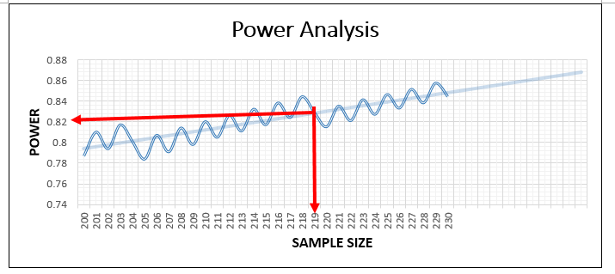

The above scenario concerns a basic bivariate relationship that looks at the difference between groups without any covariates. With the addition of covariates, we see a change in the number of cases required to discover a true statistical difference between groups. It is important to recognize that the measurement of each variable (i.e., binary, ordinal, continuous) influences the results of the power analysis. As demonstrated in Figure 2 below, when we add four predictors to our model (age, income, gender, and time served on the current sentence, the required total sample size increases to 612 (n=306 per group). Obtaining a sample of this size would require remaining in the field longer, and have associated costs. In order to achieve an appropriate sample size, while recognizing the cost-benefit of adding further power, it was determined the study will have adequate power at n= 220 per group.
Figure 2: Required Total Sample Size for Model with Four Predictors
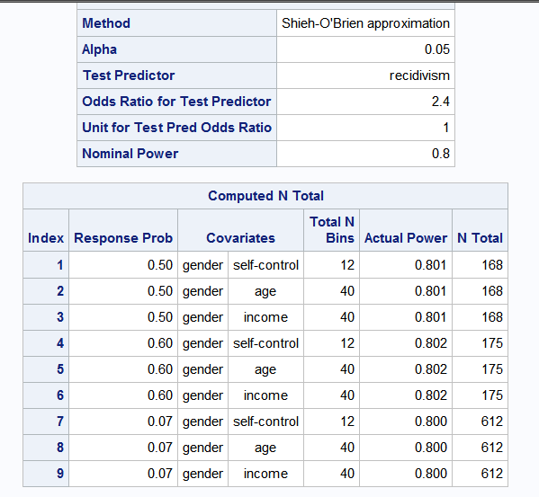
The sample will be comprised of approximately 220 people who receive the intervention. Followed an informed consent, face-to-face interviews will be conducted. In the formative evaluation pilot conducted under Phase III of NCJRP, well above 90% of persons approached to participate agreed to participate. The comparison group will be created by selecting persons released from DOC in the same time frame who possess similar demographics, criminal justice histories, LRI-R risk scores, but who did not receive the intervention. Because the comparison sample will be selected statistically at the end of the field portion of the study, as described below, they will not be eligible for the face-to-face interview portion of the study.

Data and Analytic strategy
Data will come from three sources. 1) Face-to-face interviews with program participants, 2) program and institutional data from the Delaware Automated Corrections System (DACS), and 3) the Delaware Criminal Justice Information System (DELJIS). Each is briefly outlined below.
1. Face-to-face According to the recently released Limits of Recidivism report (2022), research should “consider[s] the role of contextual conditions in shaping post-release outcomes and the value of self-report and qualitative data in evaluation of success.” We thus propose to conduct face-to-face interviews with all participants prior to release from prison, with follow-up interviews at approximately 30 and 180 days post-release. The purpose of the interviews is to obtain detailed information on reentry and desistance, and how programming prepares (or does not prepare) individuals for community reentry. Data will be collected at baseline on known criminogenic risks factors, self-control, mental health and well-being, as well as optimism and procedural justice/legitimacy measures and treatment satisfaction measures. Follow-up interviews will repeat certain baseline measures and obtain housing, employment, and relationship data as well as self-reported criminal activity. All interviews will utilize validated scales. Each interview will contain a short qualitative component to supplement the quantitative data and provide nuance to the evaluation. This will consist of four to five open ended questions dealing with participants’ current situation at baseline, approximately 30 days and 180 days post release, respectively. This portion of the interview will be recorded and transcribed for analyses. We plan to conduct interviews at 30 days post release to assess the impact of immediate reentry issues. Interviews conducted at 180 days will follow up on the baseline and 30 day questions, and will also be used to assess longer term reentry and desistance metrics.
The research team, in collaboration with DOC, will identify persons soon to be released from participating prisons based on release date. Eligible persons will be those who have participated in the CBT-Training Intervention and are leaving the institution in 30-60 days.
Once a list of eligible adult persons is identified, UD team members will arrange to have them called to a meeting to discuss the project and recruit volunteers. The recruitment script will be read to them. Corrections counselors will assist with the process.
The recruitment script includes language indicating that participants will be interviewed prior to leaving the facility, that their records will be obtained from DELJIS after they are released and that researchers intend to interview them 30- and 180-days post release. UD will inform them that they will be collecting locator information and ask for contact information for additional family and or friends who can help in locating them if needed. Subjects will be informed that researchers will not tell family and friends why participants are in a study or that it is criminal justice related. UD will only tell family and friends that participants are part of a UD study and researchers are trying to locate them for an interview.
Volunteers will be informed that we intend to collect their criminal justice data after release from prison and that the data may be collected up to three years post release (it is possible the research team will analyze data beyond the project end date). Participants who volunteer will be interviewed in a private room at the facility, either in person or via ZOOM if conditions mandate it. Having identified the cohort, we will obtain LSI-R, RNR, and other demographic and criminal history data from DOC and program data from providers. We will re-contact the sample in the community for a follow-up interview 30 and 180 days post release to conduct follow-up interviews. In the NCJRP Phase III formative evaluation, the UD team maintained an 87% follow up rate for community interviews conducted approximately 30 days post release. Thus, we are confident that we will be able to achieve an adequate sample of interviews for analyses.
The research team will receive administrative DACS and DELJIS data on all participants. Only those who consent to be interviewed comprise the sample of persons for whom the more in-depth data are available. Their data will be linked to the DACS and DELJIS data (described below) for analyses.
- Data from DACS will be used to obtain LSI-R scores, RNR tool recommendations and program data, including dates of enrollment and completion status. (See NCJRP Data Infrastructure Plan and Phase III Formative Evaluation Report for details on administrative data).

- Data from DELJIS will be used to obtain criminal history information as well as post release arrest and incarceration data. (See NCJRP Data Infrastructure Plan and Phase III Formative Evaluation Report for details on administrative data).

Outcomes: Recidivism and Beyond
Recidivism
The definitions of recidivism to be used in the analysis are:
- 12-month post release recommitment – the first secure custody readmission (excluding administrative recommitments) during the at-risk period
- 12-month post release rearrest – the first incident of arrest during the at-risk period for any qualifying offense.

As the figure below from the Statistical Analysis Center (SAC) shows, the majority of recommitments and rearrests in their three-year report occurred in the first 12 months. Like the SAC, our analyses will count only what the SAC refers to as serious criminal offenses, defined as offenses identified in the Delaware Code as felonies or misdemeanors with incarceration as a possible (or mandatory) sanction, in addition to probation and parole violations.

Figure 3: Recidivism in Delaware Table for SAC’s 2021 Recidivism in Delaware Report.
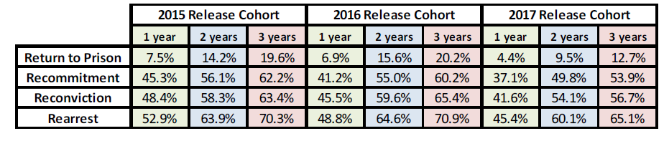
Analytic Strategy
While the gold standard of randomized trial will not be applied for this study the Delaware DOC is using evidence based practices to assign people to treatment based on LSI-R scores and RNR tool recommendations. Because we need to adjust for the lack of randomization in assignment to groups, multinomial propensity score weighting will be used to create groups that are balanced on our covariates of interest (e.g., race, gender, age, court ordered participation, and LSI-R level). We have used this procedure successfully in our evaluation of the Delaware KEY/CREST treatment programs. The procedure is explained in more detail below.
The UD evaluation team will employ case matching techniques to statistically model the differences between groups. UD will analyze the data twice, once with the standard bi-variate outcome analyses, then with the weighting procedure employed. The analyses will first be conducted as differences between the groups presented as percentages with no controls to account for group differences. This is the most straightforward and easily interpreted way to present the data.
The weighting will utilize multinomial propensity score weighting. This strategy is a nonparametric approach that assigns weights to individuals from the treatment group that make them statistically identical to those in the comparison group on observable factors like race, gender, age, court ordered participation, and LSI-R level (McCaffrey et al., 2013). All individuals from the treatment and comparison groups are kept in the analysis, but weights help to identify subsets of individuals across all that serve as counterfactual comparisons for arrest and incarceration events. The weighted sample size will then be smaller than the total sample size.
The weighting will be conducted in four steps. First by generating a set of multinomial propensity scores, we will calculate weights that account for any non-equivalence between persons. We will also designate whether a person fell into one of two groups: Comparison, or CBT-Training Intervention. Next, we fit a generalized boosting model (GBM) predicting whether a person falls into one of these groups relative to being in any of the groups as a function of relevant individual and case characteristics as well as any interactions among these variables. We will use the propensity scores from the GBMs to calculate a set of average weights that achieves the “best balance” in covariates between the individuals in a specific group (e.g., comparison group) and the rest of the sample (McCaffrey et al., 2013). While we retain all members of the comparison group, reweighting groups to be statistically similar to one another decreases the number of individuals in the treatment group. In the final step, we tabulate the outcomes using these weights to effectively reduce the role that distinctions in the demographic and legal and risk composition of groups play in creating differences in outcomes and better isolate the effect of treatment on arrest and incarceration events (Stuart et al., 2014).
Beyond Recidivism
The field of Criminology/Criminal Justice over the past decade has begun to realize that, because desistance is a process containing stops and starts, more nuanced measures of success need to be considered that move beyond traditional measures of rearrest and reincarceration. According to the National Academy of Sciences 2022 Limits of Recidivism report, researchers conducting reentry related research should focus on measures of “personal well-being, education, employment, housing, family and social supports, health, civic and community engagement, and legal involvement.” Sample size will impact the ability to utilize complex quantitative models, but bivariate correlations and simplified multivariate models cycling variables in and out to retain power will be utilized to explore the various interactions of elements confronted by persons returning to the community.
Dissemination Plan
Delaware DOC has implemented the pilot of these programs, is training DOC staff to administer them, and is conducting an initial recidivism analysis with funds provided by BJA. A complete evaluation is needed in order to garner the support from the State Legislature and others to secure funding to sustain the program and impact from the implementation during Phase III of NCJRP. Data, reports and presentations resulting from this outcome evaluation work will be published and made available to a variety of audiences, e.g., reports and presentations made to DOC and local criminal justice committees, and American Society of Criminology conferences. (UD plans to present the study at the American Society of Criminology conference at the end of years two and three). A final report will be delivered to the Delaware Criminal Justice Council and Arnold Ventures at the conclusion of the study. The data will be submitted for publishing in peer reviewed journals to disseminate to the field at large. Finally, the data will be available to graduate students at UD and other institutions for use in Master’s Thesis’s and Dissertations. In this way we plan to provide the widest possible dissemination of the findings and overall NCJRP effort.

Proposed Timeline
We propose a start date of April 1, 2023 to allow time for the UD team to obtain IRB approval and be prepared to field the study in early 2023. This will coincide with DOC program expansion. We anticipate approximately 18 months of enrollment. We realize that is ambitious, and are flexible. The timeline below is anchored to any start date.
Figure 4 Proposed Phase IV Evaluation Timeline
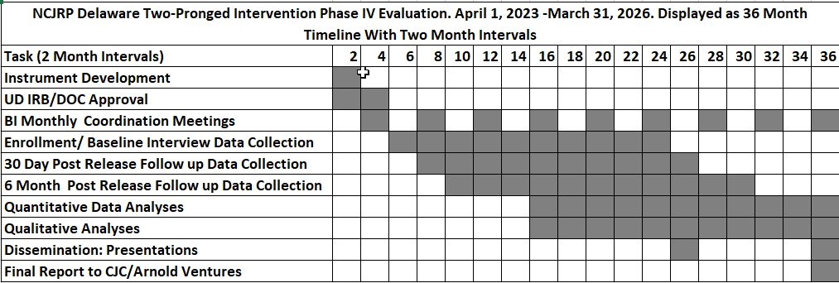

As can be seen in Figure 3 above, the study follows a typical research timeline. We plan to revise our instruments upon approval for the Phase Four evaluation, and obtain IRB approval as soon as possible. We propose that the research team (UD), Delaware Criminal Justice Council and DOC meet bi-monthly throughout the evaluation to provide updates and troubleshoot issues. Once IRB and DOC research approvals are in place, UD will begin enrolling subjects as they near release (within 30 days prior to release). From there the timeline is set, with 30 day and six month follow up interviews tied to release dates. We plan to begin preliminary analysis of interview data as soon as a realistic sample is achieved (~100 cases).

Appendix: Personnel, Budget and Justification
Personnel
The Project will be led by PI Dr. Daniel O’Connell with support from CO-PI Dr. Christy Visher. O’Connell will be in charge of overall operations from research design and IRB approval through data collection and analyses. He has decades of experience in reentry research. He has been PI of NIJ funded RCT based studies on probation based interventions and prison based interventions of CBT programs and has conducted quasi-experimental studies similar to the current design in a recent evaluation the that Delaware KEY-CREST continuum. He will lead the field effort and will be in the field conducting interviews with other staff regularly. He will guide all analyses and be responsible for overall dissemination. He will devote 40% FT effort in years one and two, dropping to 33% in year three.
Co-PI Christy Visher is an internationally recognized expert in reentry, whose recent research focus has included new ways to measure recidivism and post prison success. She will consult on instrument design with a specific focus on success measures other than rearrests and reincarceration. She will devote 4% FT effort in years one through three.
Ellen Donnelly is an Associate Professor in the UD Department of Sociology and Criminal Justice, and an expert in statistical modeling. She is also UD’s expert in converting DELJIS data from administrative data to analyzable data sets. She will with the PIs to model the outcome data. She will devote 4% effort in all three years.
Funds are requested for one 75% and one 25% TBD research associates. These will be experienced researchers already in CDHS employ who will shift to the NCJRP project upon project launch. The remain TBD because CDHS has numerous staff who could fill these roles. They will work under the direction of PI O’Connell to conduct interview and fidelity assessments and compile data sets. The 75% position will drop to 50% in year three upon completion of the data collection. They will assist with analyses and report writing in year three.
Funds are requested for one full time (20 hours per week) Ph.D. Candidate graduate student to assist in all phases of data collection and analyses.
Fringe Benefits
The UD Fringe rate is 39.1% for staff and 13.1% for graduate students. There is no fringe for summer graduate student effort.
Local Travel
Funds are requested for local mileage at $0.625 per mile to travel within Delaware to conduct interviews and fidelity assessments and attend meetings. Between field interviews, fidelity assessments and meetings we anticipate being in the field weekly or more (daily at the peak of data collection). DOC meetings will be set on an intensive pace in the early stages (weekly across the different facilities), tapering off to monthly and less as the study progresses.
Conference Travel
Funds are requested at $3,500 per year to send two people to conferences such as the American Society of Criminology or the American Correctional Association.
Supplies
Funds are requested for supplies for professional fees, meeting expenses, office supplies, computers, copying/printing, book/manuals, computer software and survey printing.
Respondent Fees
Study participants will be paid $25 for baseline interviews and $50 for each of the 30 and 180 day follow-up interviews. These funds are requested in years one and two.
DOC Overtime Funds
Staff shortages can lead to programing being canceled temporarily due to lack of security staff coverage. Funds are requested by DOC to pay overtime for staff to cover CBI-EMP or Five-for-Five sessions as needed. These funds are requested in years one and two.
Tuition
The University of Delaware requests funding for partial tuition for graduate students. These funds are not subject to F&A.
F&A
Arnold Ventures allows a 15% F&A rate. The University will accept this rate.
Delaware Criminal Justice Council
The Delaware Criminal Justice Council requires 10% of direct costs to administer the grant. These funds are not subject to UD F&A.

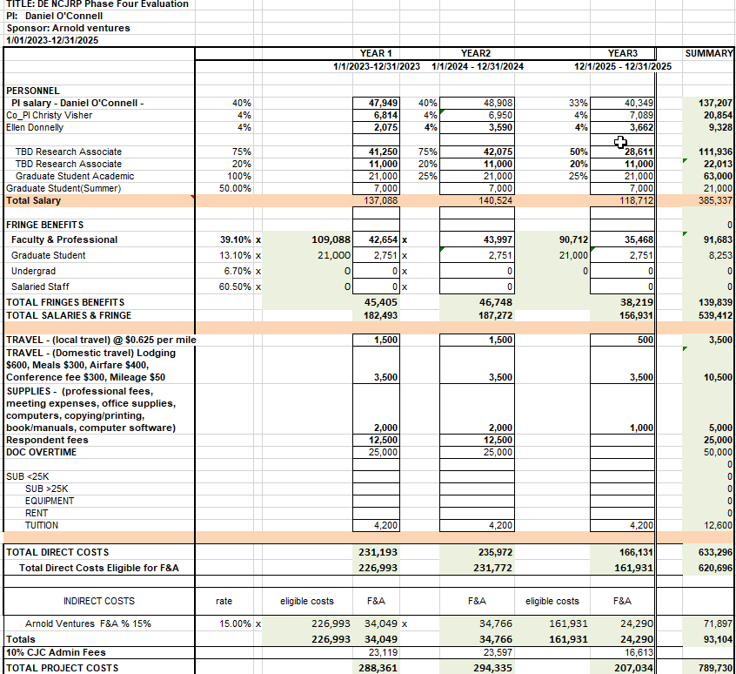

NCJRP supports person-first language; this is term used in the materials referenced here.
https://nicic.gov/projects/cognitive-behavioral-therapy
Shawn D. Bushway & Robert Apel, Overview of: A Signaling Perspective on Employment-Based Reentry Programming: Training Completion as a Desistance Signal, 11 CRIMINOLOGY & PUB. POLLICY 17 (2012).
Statistical power could be increased by extending the study length. For example, by adding six months to the study, which would potentially add 57 participants, would bring the sample to 285.
https://nap.nationalacademies.org/catalog/26459/the-limits-of-recidivism-measuring-success-after-prison

